Puneet Gill

Justin Kuo

Dang Tran

Sean Coggins

Christine Yang

NBA 3 Point Shots: Summary and Analysis

To investigate the extent of the ongoing “3 Point Revolution” in the NBA, we asked the question: “How do three pointers affect the game?” There are many paths to investigating the phenomenon, so we chose four specific questions we felt were both relevant and able to be modeled with our current skills.

Our presentation’s four central questions:

* How does the percentage of points scored by three pointers compare over time?

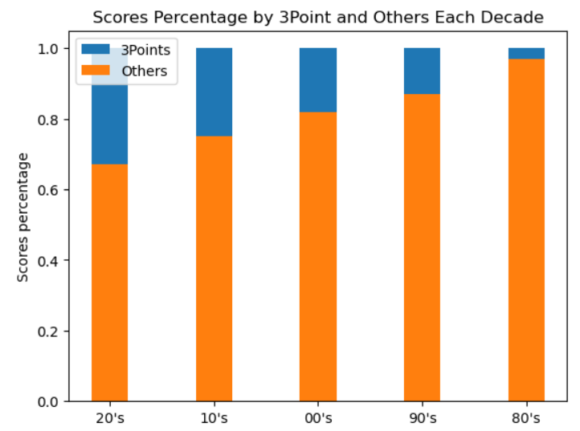

The three point shot was rarely used in the decade following its introduction, where it tallied only for a few percentage points of the total points scored.. Since then, it has increased somewhat steadily until it has become arguably a core part of NBA scoring by accounting for about a third of all points scored.

* How has the average three-point attempt quantity and accuracy changed over time?

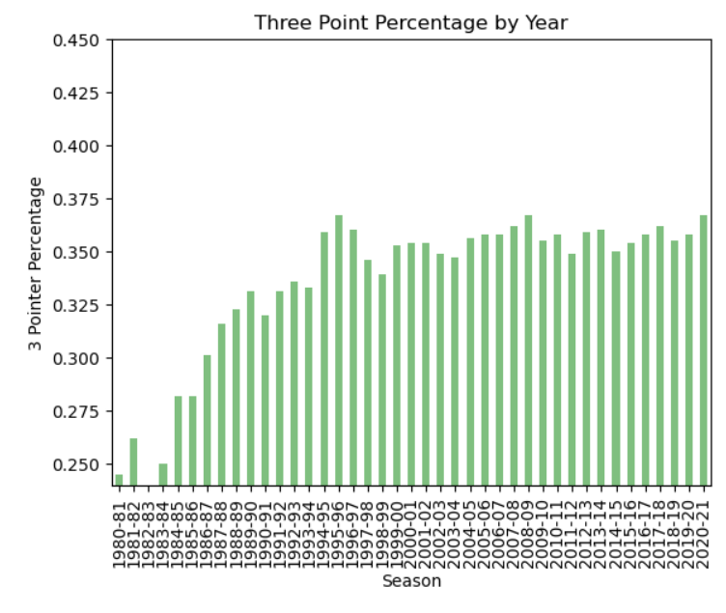

Three point shot accuracy was relatively quite low in the 1980’s, where it averaged under 30% for nearly the whole decade. It steadily increased until leveling out in the 1990’s, where it was and continues to be about 35%.

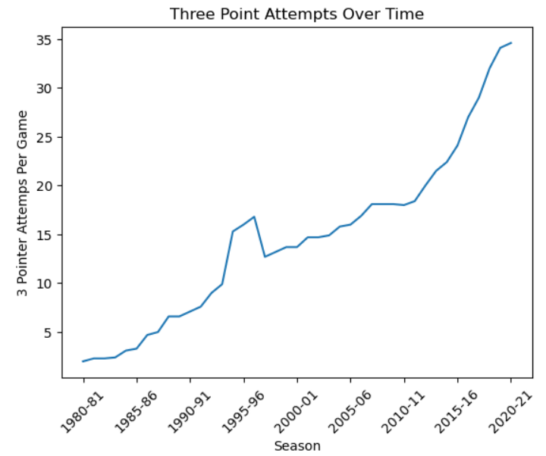

Three point attempts, meanwhile, have increased almost constantly since their introduction. Notably, since the 2010 season, the average number of attempts has nearly doubled from 18 to 35. This accounts for the largest increase in 3 point scoring, since the 3 point percentage has mostly held steady.

* How do the three point percentage and number of three point attempts affect a team’s win rate?

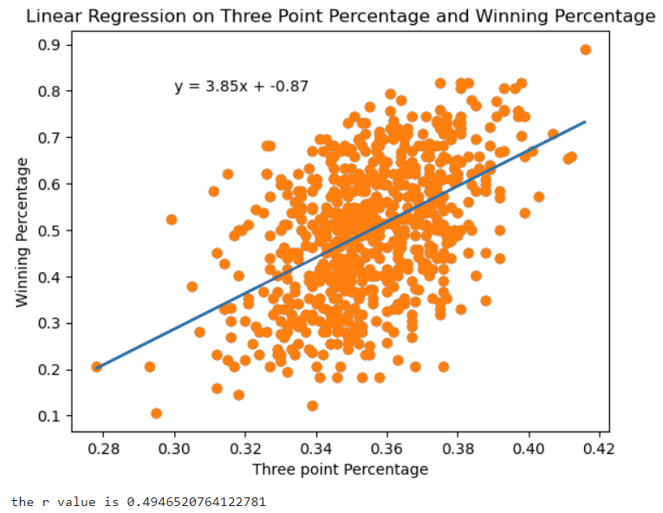

From our dataset of all NBA teams from the 2000’s, we found a strong correlation between a team’s winning percentage and a team’s three point percentage (r value = .495). Since more threes are being taken and they continue to make up a larger share of points scored in an NBA game, this is fairly intuitive.

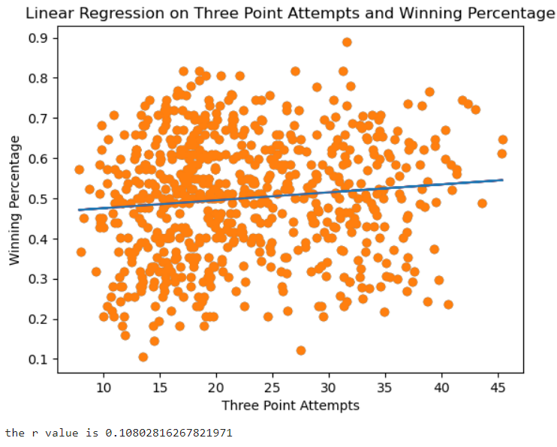

On the other hand, the correlation between three point shots attempted and winning percentage is quite weak. While an r value of .108 is not necessarily negligible, we can conclude that shooting threes at a high percentage is much more important to winning than shooting threes regardless of accuracy.

* How does the three point percentage compare between winners and losers of the NBA Finals?

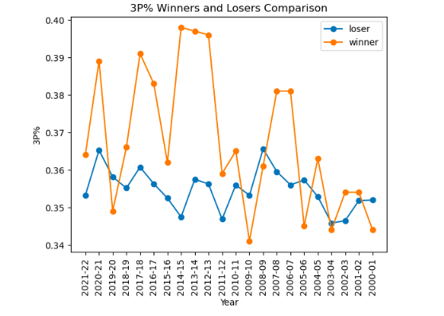

While our data for NBA FInals winners and losers is relatively limited compared to our league-wide, season-long data sets, an interesting trend came up while creating this graph. While the team with the lower three point percentage was able to prevail in four of the ten NBA Finals dating 2000-01 to 2009-10, the winners from each year afterward held the higher three point percentage in every season except for the 2019-2020 season (and often by multiple percentage points!). Considering the frequency of success of these teams, we can say with some level of certainty that three point percentage is just as important in the NBA Finals as it is in regular season play.

* Implications

After our research, we agree with the popular sentiment that the three point shot’s role in the NBA is changing. While players are not necessarily making threes with higher accuracy, they are shooting them at a higher frequency and they are accounting for a higher amount of the points scored than in any era in NBA history. Teams with relatively high three point shot accuracy have been able to leverage this trend to great effect with more regular season wins and even better performance in the NBA finals.

We feel during this study, we have only scratched the surface of this phenomenon. For further research, we feel many more insights can be discovered both at the individual NBA level and also in other basketball leagues including the WNBA and NCAA.